

Mohammad Ali Jinnah University

Chartered by Government of Sindh - Recognized by HEC

**Assignment 1**

**Name:** Muhamad Fahad

**Id:** FA19-BSSE-0014

**Subject:** [Linear Algebra (Fall 2020)](https://classroom.google.com/u/0/c/MTgxNTU3ODEwMjQw)

**Section:** AM

**Teacher:** Dr. Asmat Ara

**Date:** Wednesday, October 28, 2020

**Attempt all questions.**

Q.1 (a) Evaluate the matrix

into Reduced Echelon form.

**Solution:**

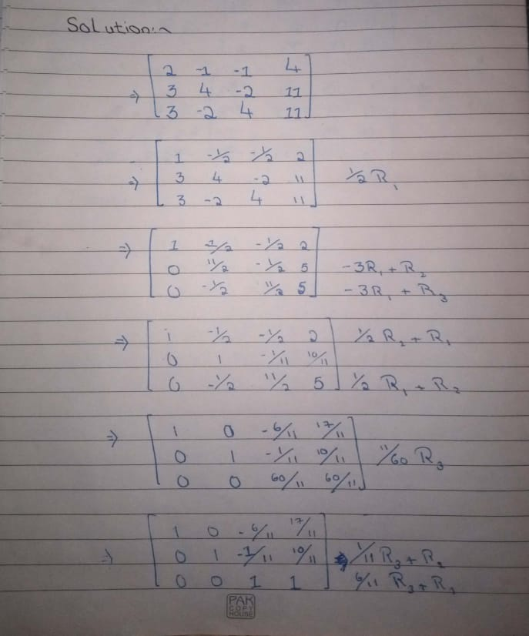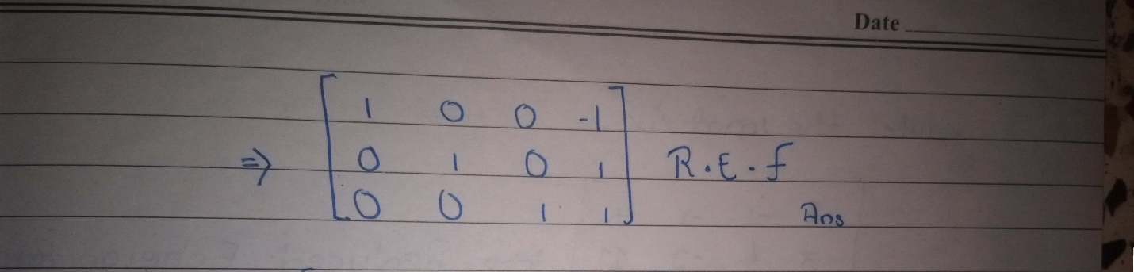

(b) Evaluate the matrix

into Echelon form.

**Solution:**

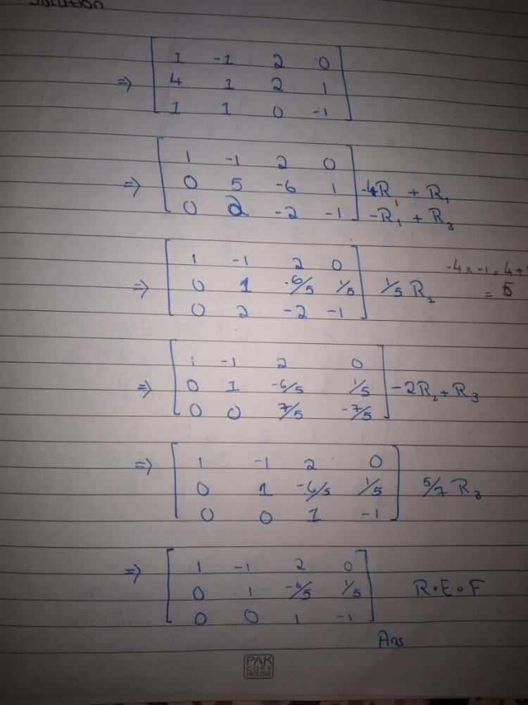

Q.2 Solve the following system by Gaussian Jordan method.

**Solution:** 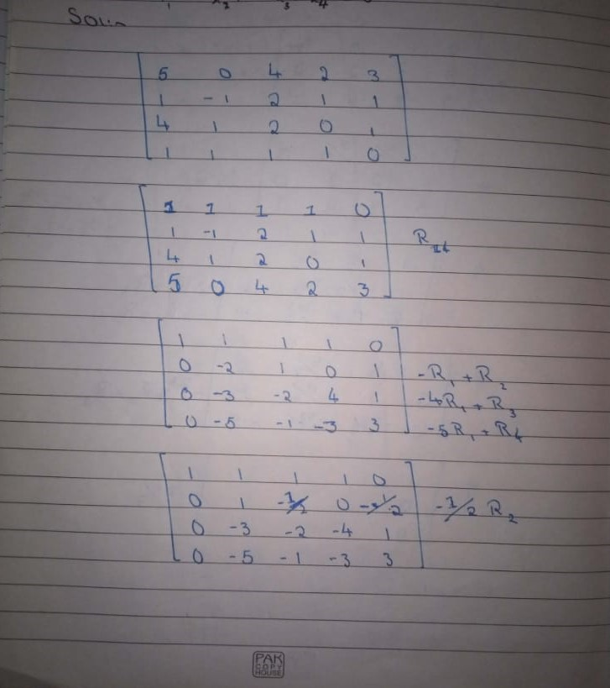

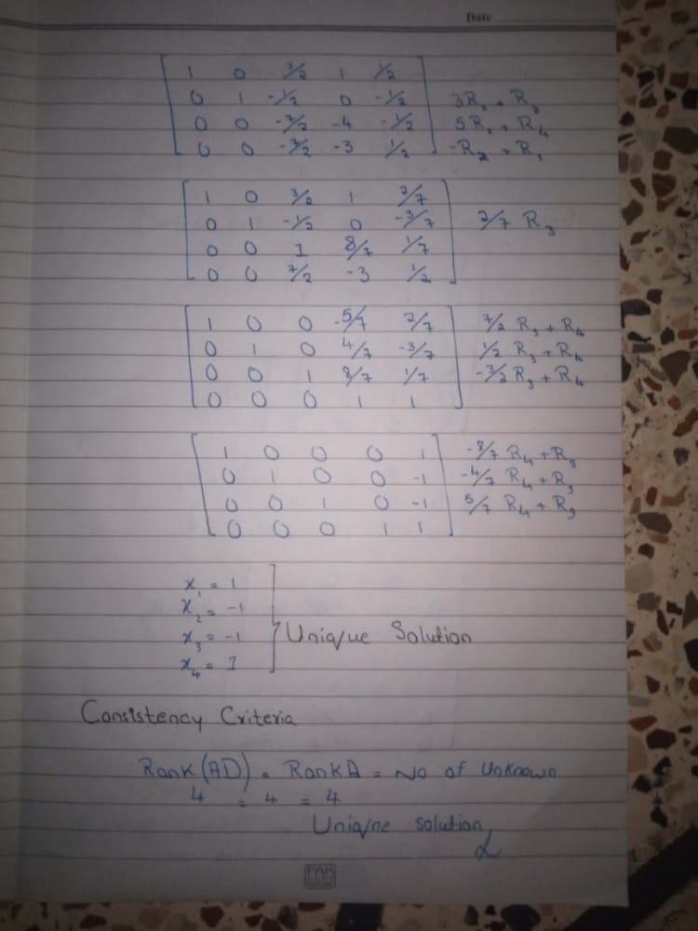

Q.3 Solve by elementary row operations.

**Solution:** 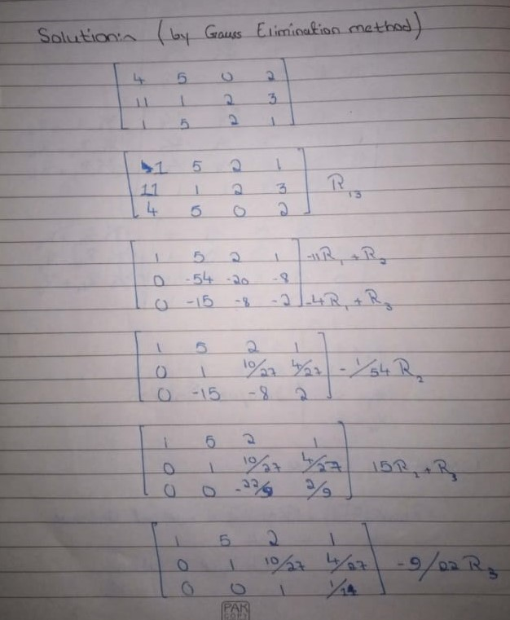

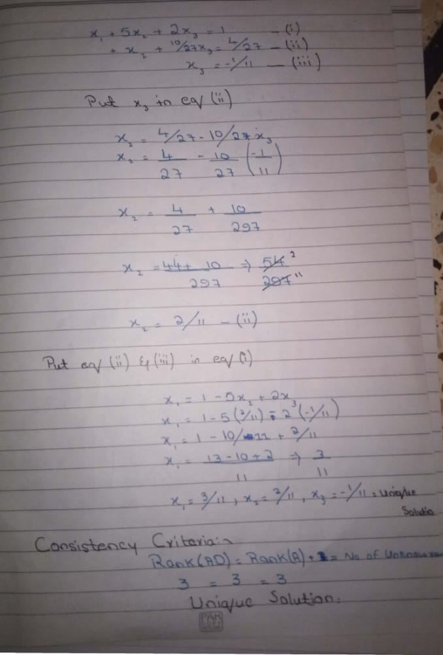

Q.4 Solve by elementary row operations. (by Gauss Elimination)

**Solution:** 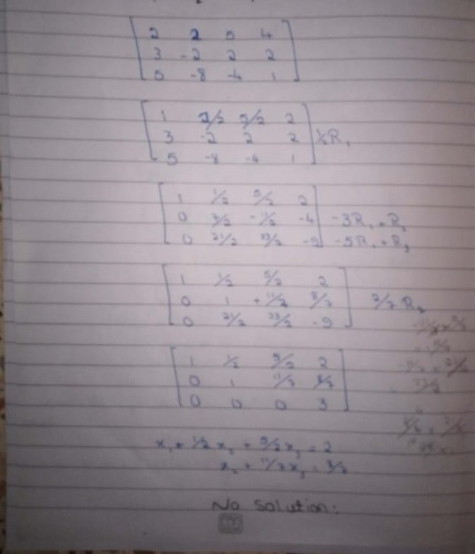

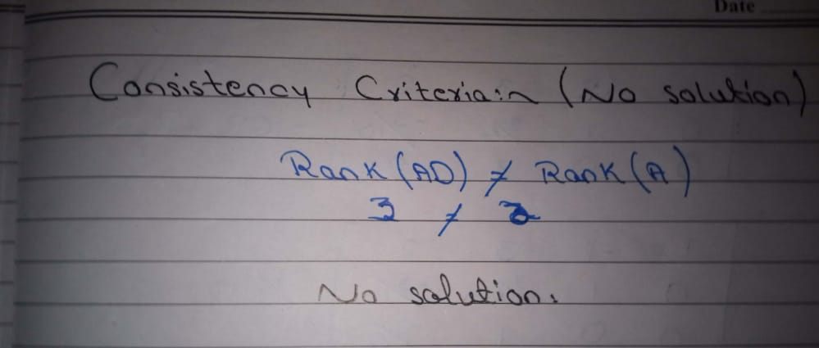

Q.5 Solve by elementary row operations. (by Gauss Elimination)

**Solution:** 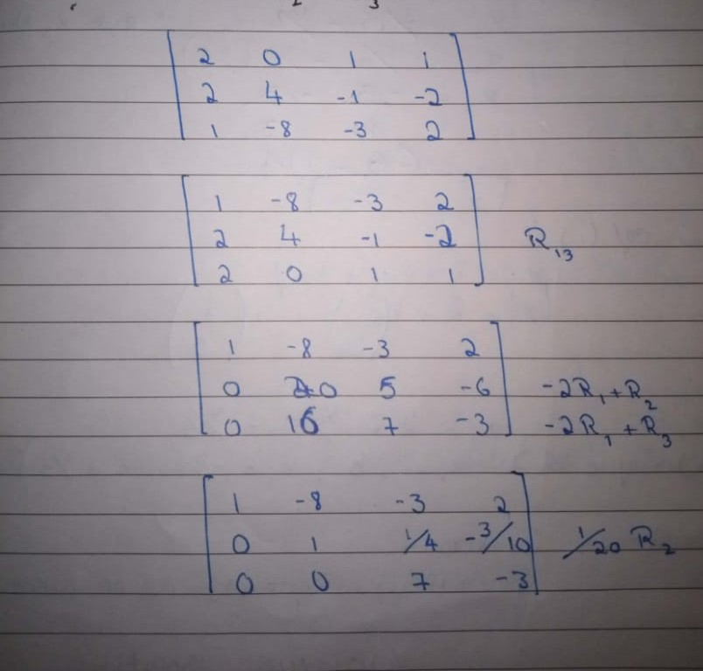

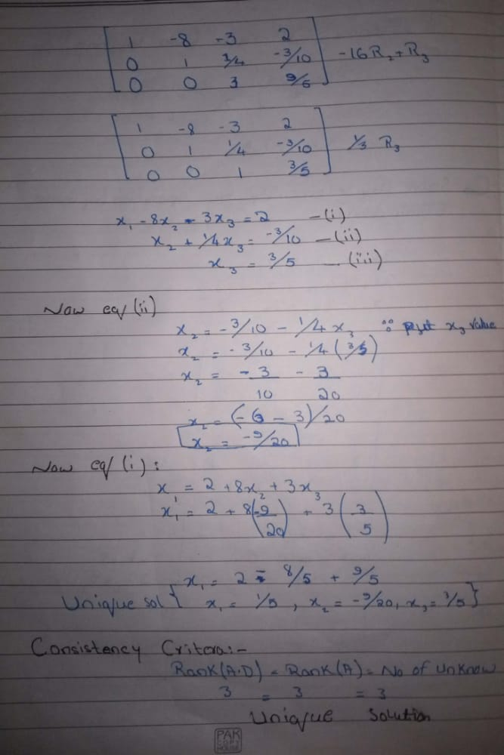

Q.6 Solve by elementary row operations. (by Gauss Jordan)

**Solution:** 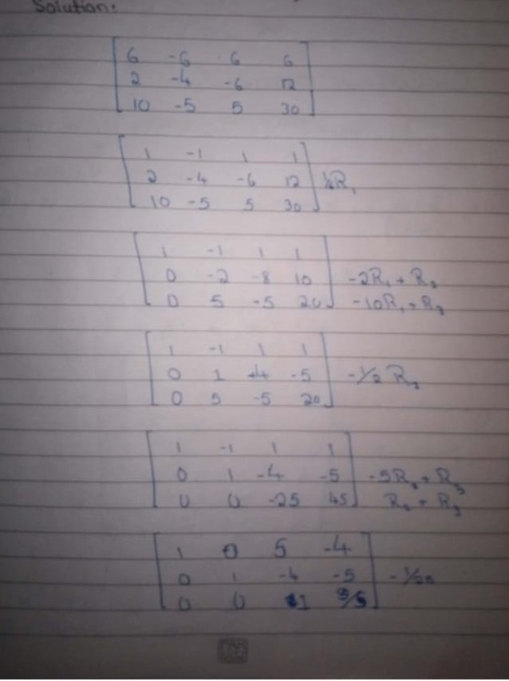

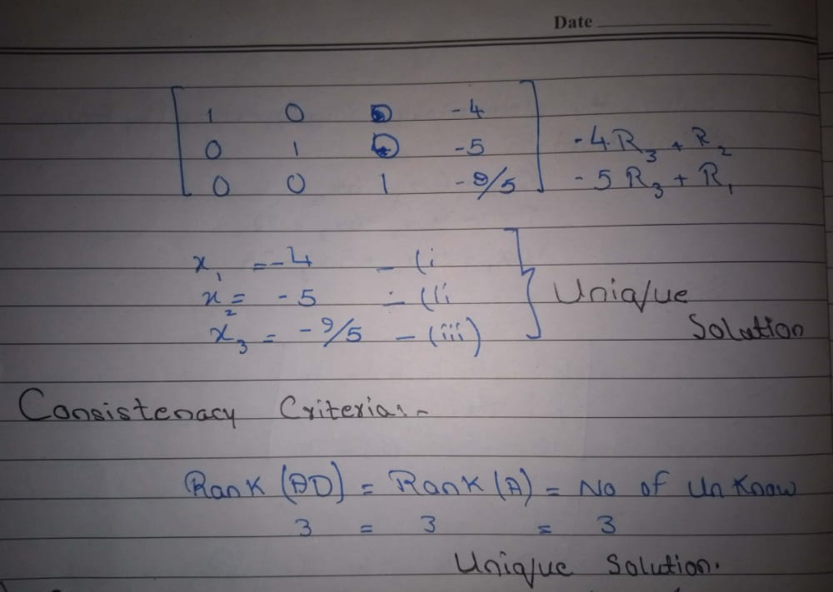

Q.7 Solve by elementary row operations. (by Gauss Jordan)

**Solution:** 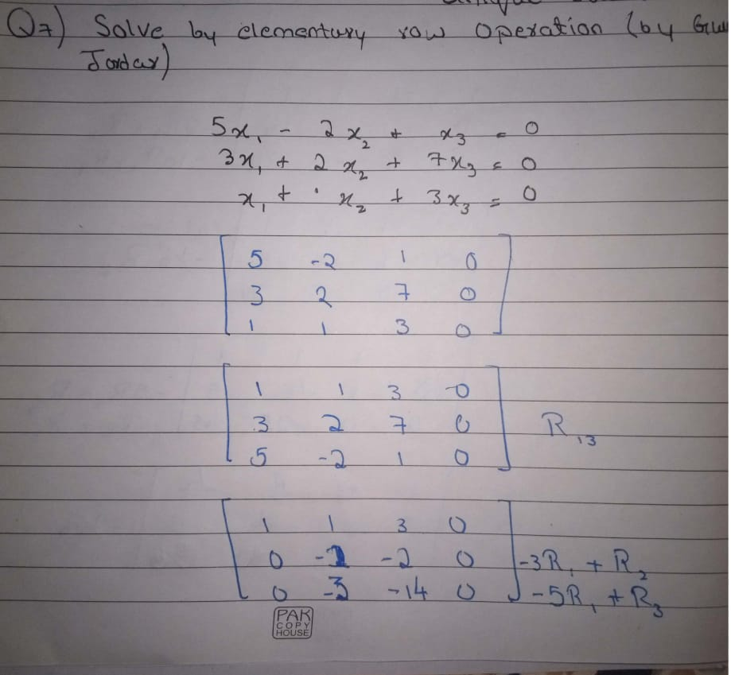

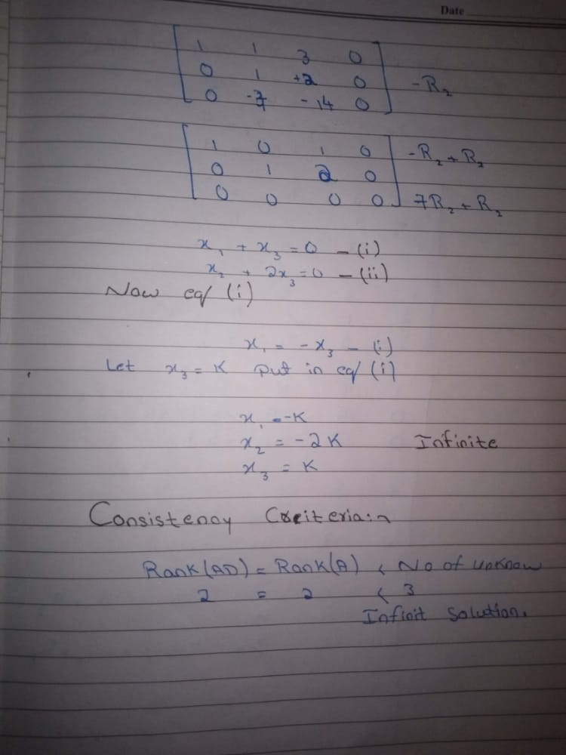

Q.8 Solve by elementary row operations. (by Gauss Jordan)

**Solution:** 